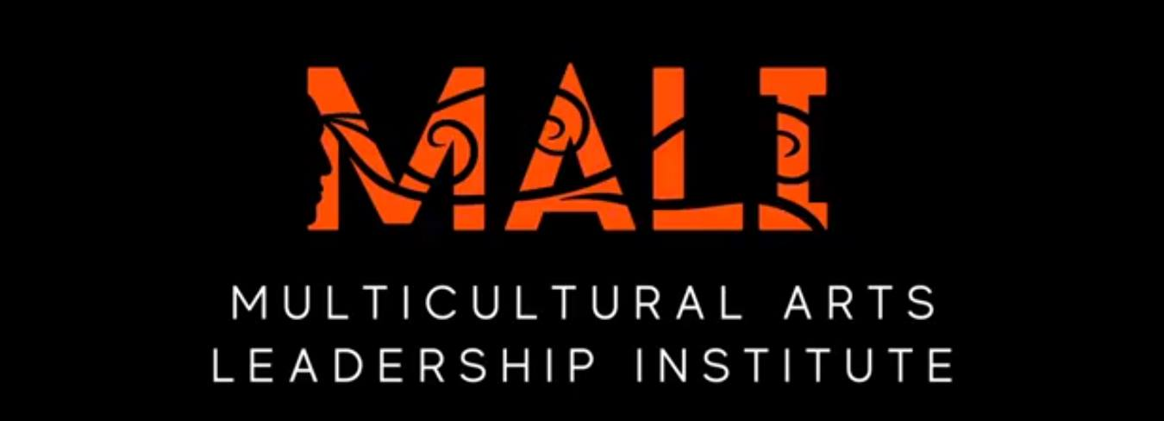

MALI Class 15 Application Form – 2023-24
School of Arts and Culture, Mexican Heritage Plaza
Application is due by February 13, 2023

Helpful Tips:
Character count limits listed under narrative responses include each letter and space. Please be concise.

Please send this application word doc plus your resume to:
Roy Hirabayashi
roy@schoolofartsandculture.org

BASIC INFORMATION Please indicate your current place of residence.

Full name:

Residence address:

City: Zipcode:

Cell phone:

Other phone contacts:

Email:

Employer:
Address:

Self-employed: Yes____
No____ Business name:

LIVED EXPERIENCES

How did you hear about the MALI program?

Please describe your artistic discipline(s). (music, dance, spoken word, visual arts, etc.)

Your Story
Tell us about your story. How did you begin your creative journey?
Character Limit: 2000

Leadership
Tell us about your leadership experience.
Character Limit: 2000

Background
Describe your background and lived experience as a person of color.
Character Limit: 2000

Values
At the School of Arts and Culture, our organization values are Creativity, Heritage, Inclusion, Place, and Service. Tell us how you have embodied one or more of these values in your work.
Character Limit: 2000

WHAT ARE WE MISSING? Missing Pieces?
Are there other facets of your lived experience that you would like to share that we may have missed?
Character Limit: 2000

Resume
Please attach a resume that is no more than two pages long. Please include contact information, educational background, recent work experience, current creative/artistic projects/events, awards and recognitions, related training/workshops/leadership programs, and two references with email contact information.

Applicants to the MALI program can live somewhere other than Santa Clara County. However, their creative practice and work must be within Santa Clara County.

The 2023-24 MALI 15 program will begin in May 2023. The class meets monthly generally on the 4th Monday of the month from 5:00 pm to 8:00 pm at the School of Arts and Culture at the Mexican Heritage Plaza. Some sessions may go longer than three hours. It is also required for MALI class members to do additional check-ins during the month. In addition, one class project requires other meetings to organize and produce. The MALI program ends with a two-day, overnight retreat session in April 2024.

There is no fee to participate in the MALI program. However, attendance is mandatory. Absences will be grounds for termination from the program.

For more information, please go to the MALI web pages:
https://www.schoolofartsandculture.org/leadership-development

https://static1.squarespace.com/static/5c70f584797f74142d45f7cf/t/5c849087eef1a1afdbc4c584/1552191651414/We+Are+Enough_Email+Size.pdf

Interviews are part of the application process.
Applications are due by February 13, 2023
The announcement for the MALI 15 class is in early April 2023.

